**Date:29/03/2024 Prepared By: Shrikanth C R**

**Deploy War File To Tomcat Using Jenkins Pipeline:**

**PREQUISITES:**

1. Installed Tomcat in one ec2-server.
2. Installed Jenkins in Another ec2-server.

**PLUGINS:**

1. GIT HUB

2) MAVEN INTEGRATION

3) DEPLOY TO CONTAINER PLUGIN

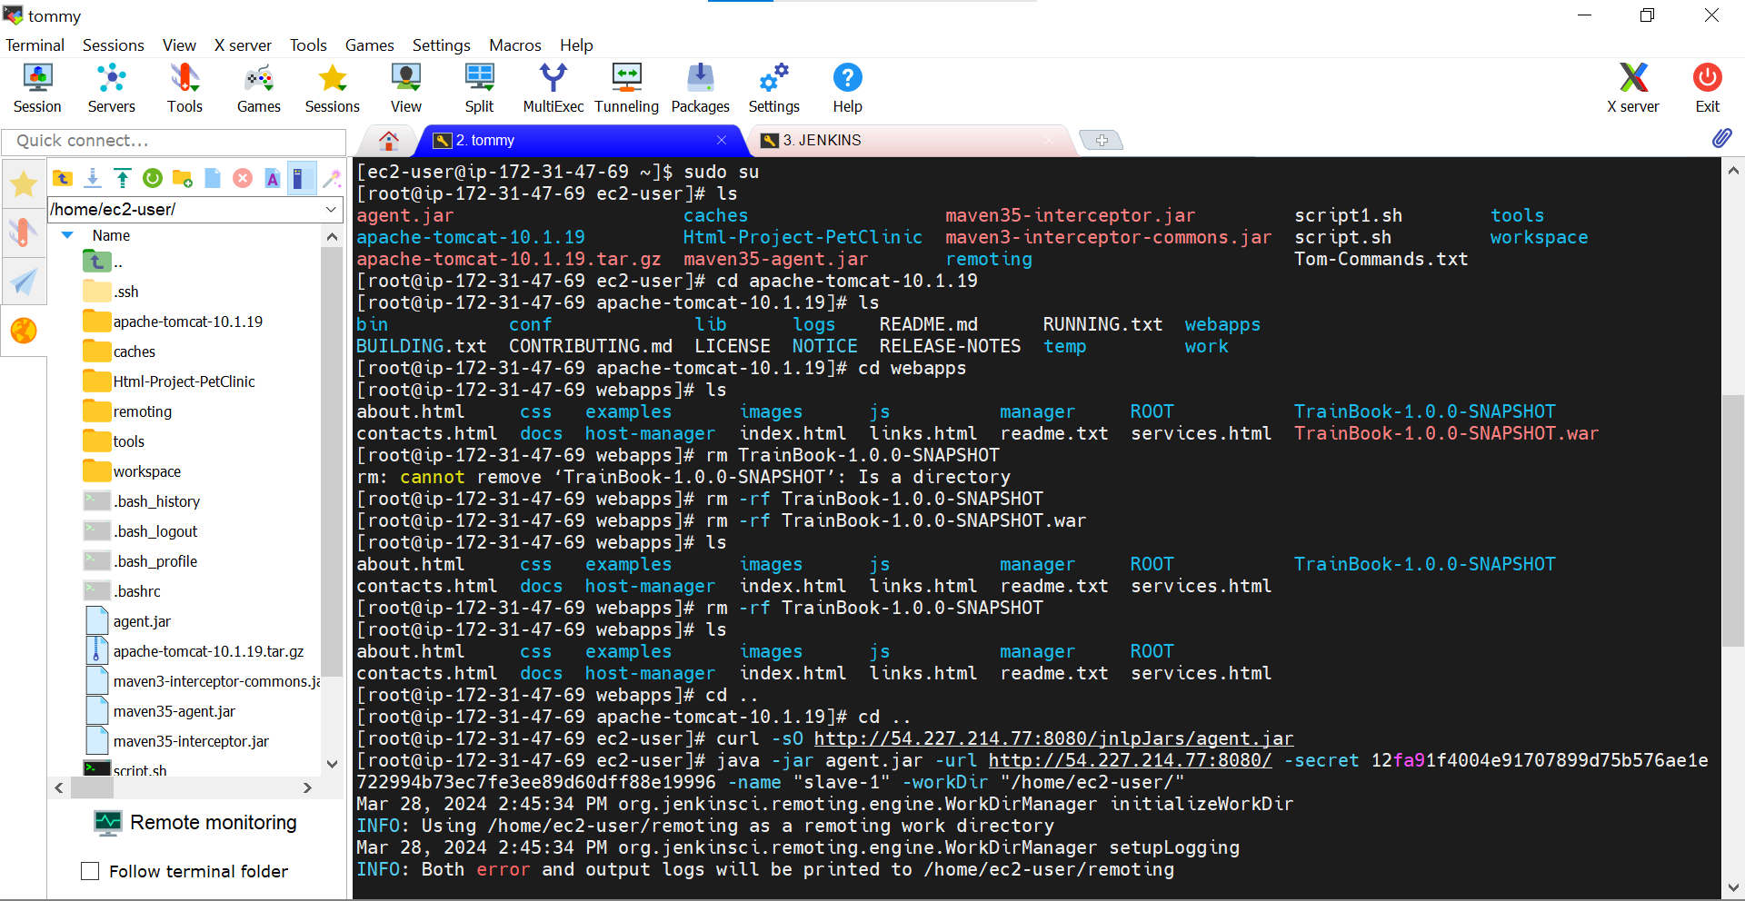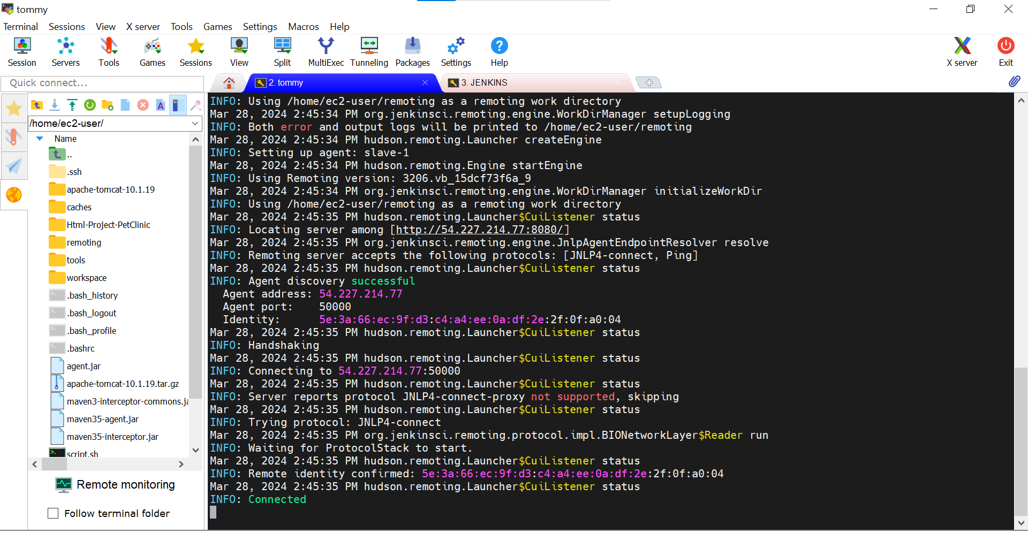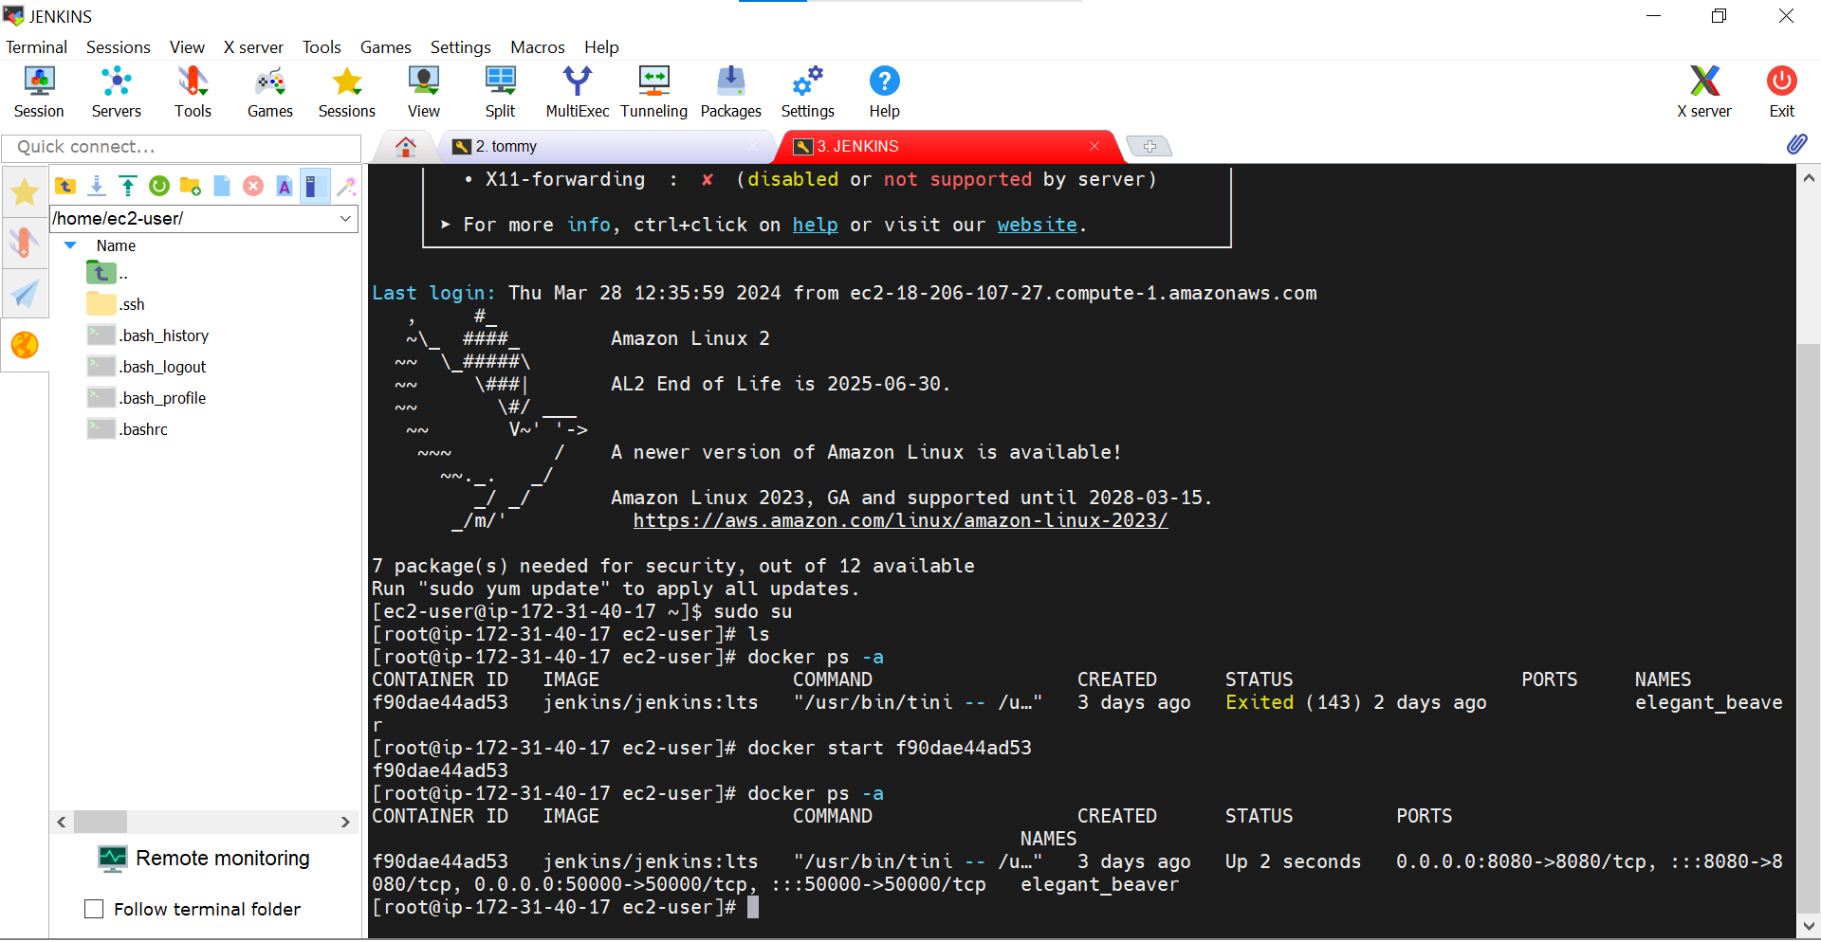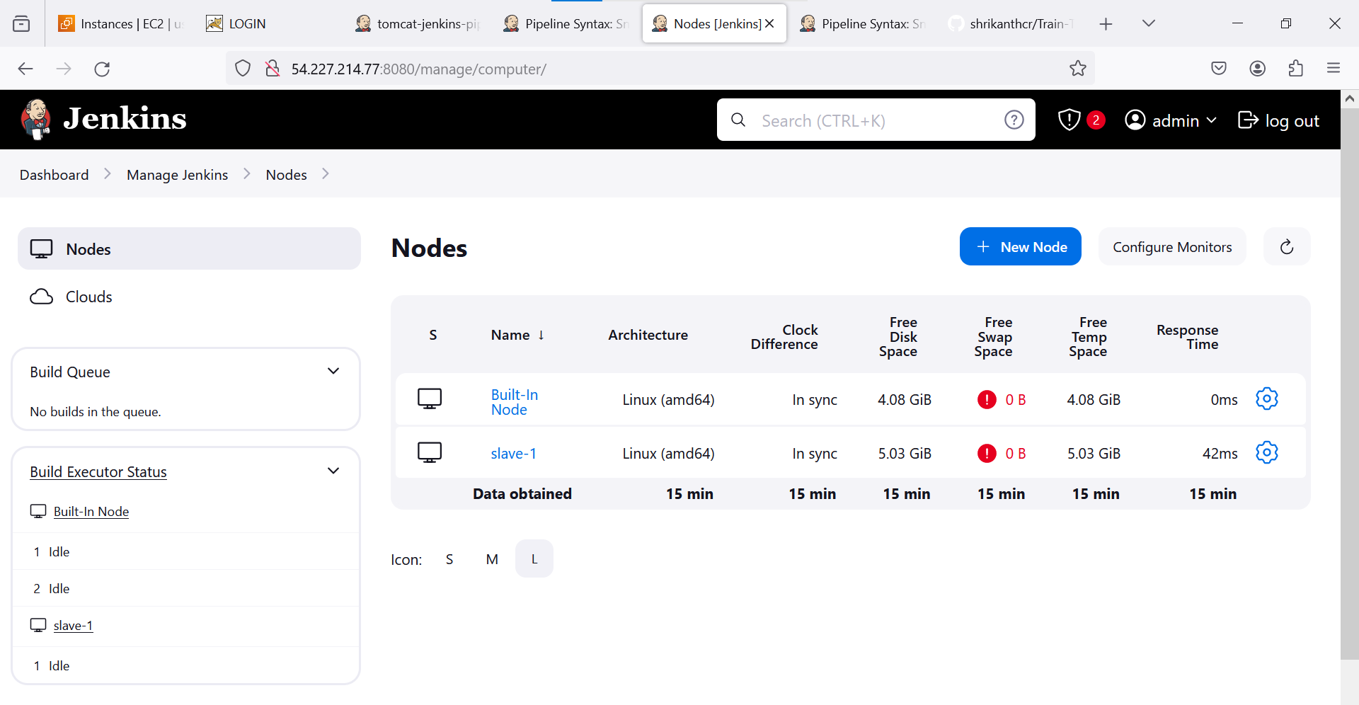

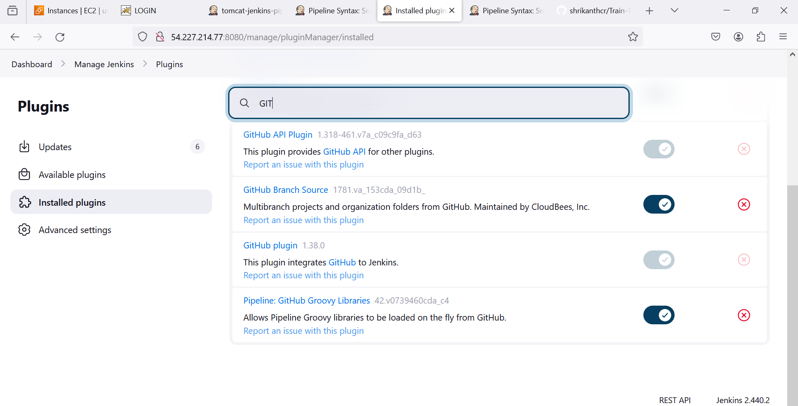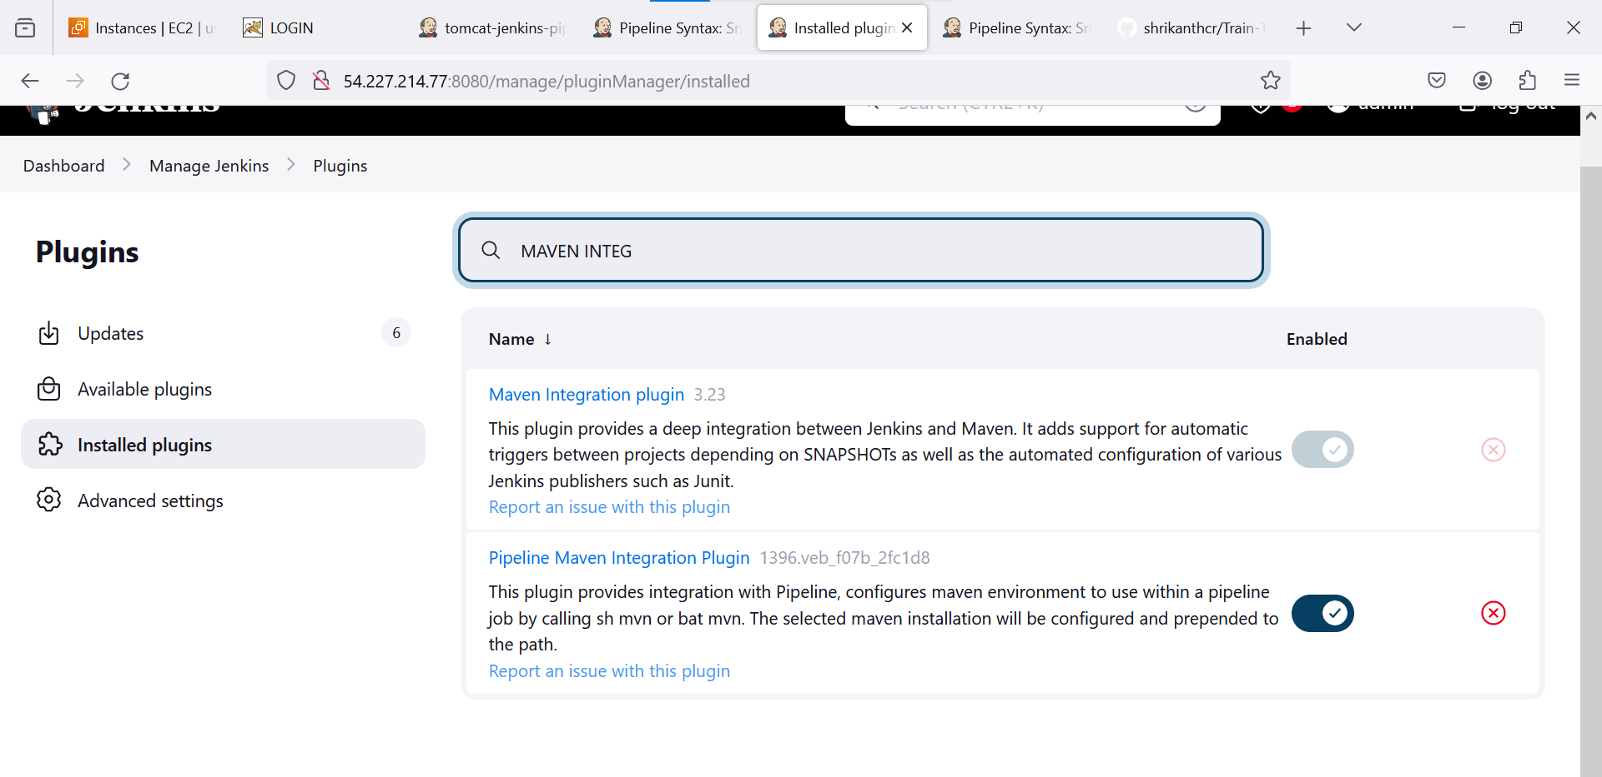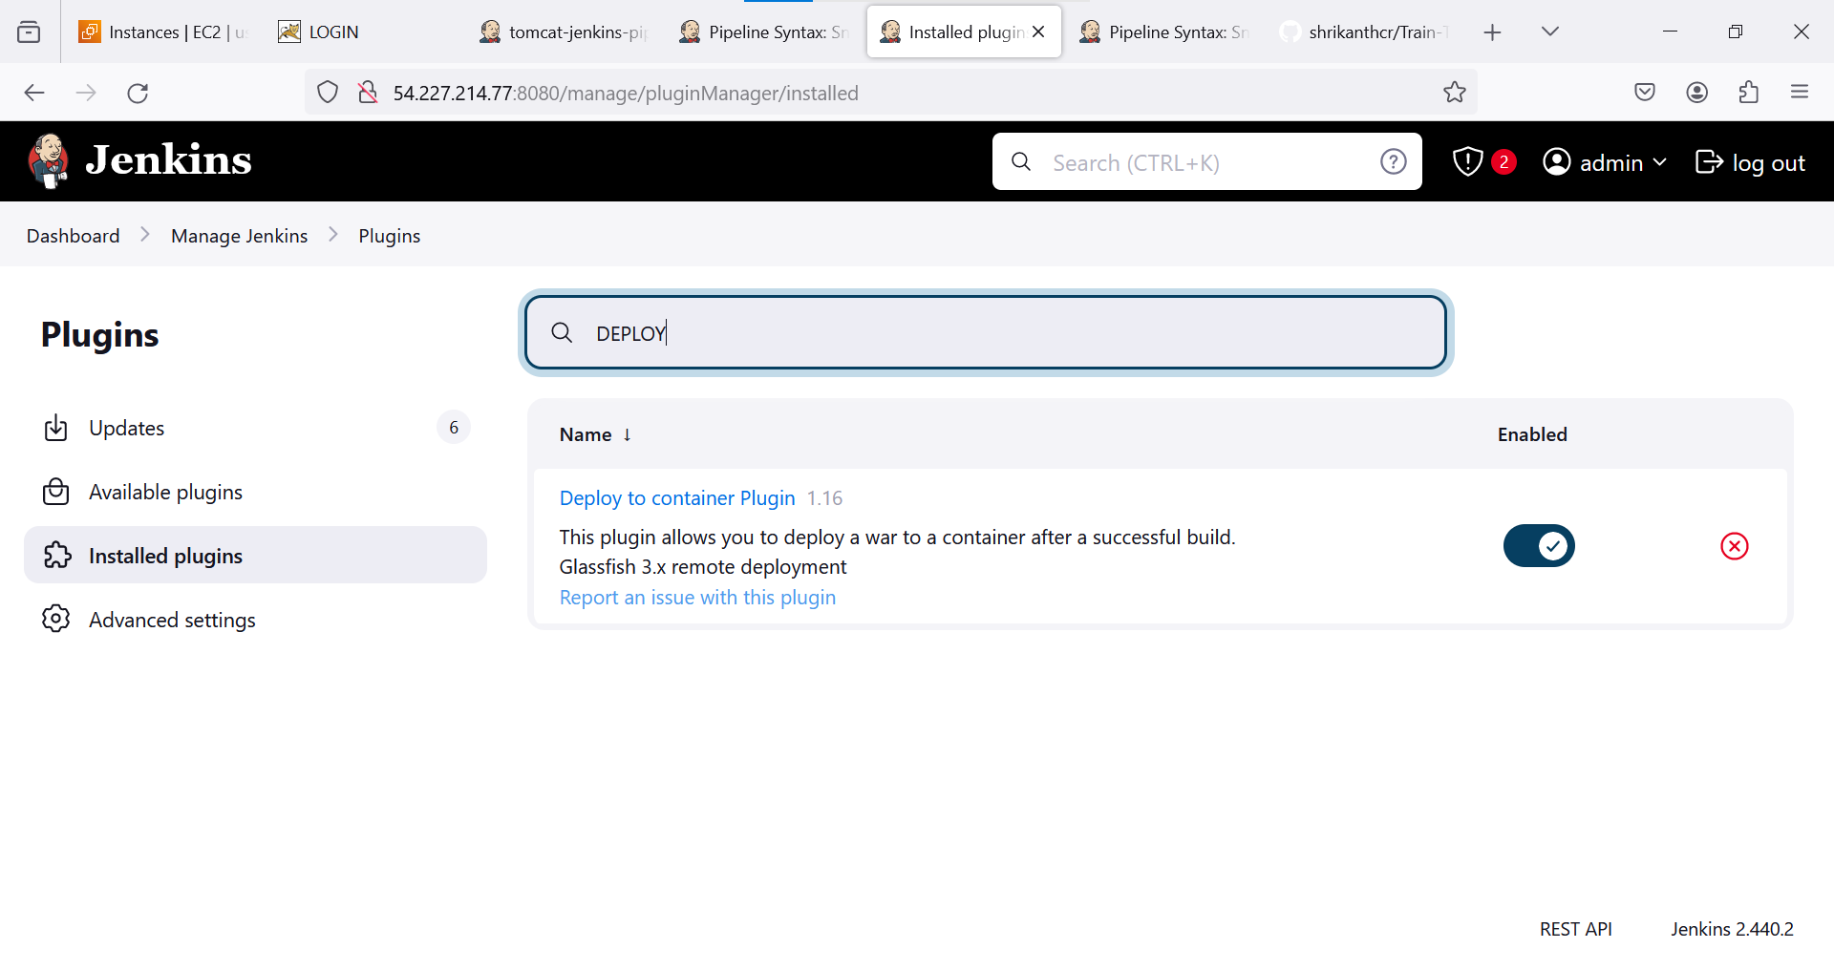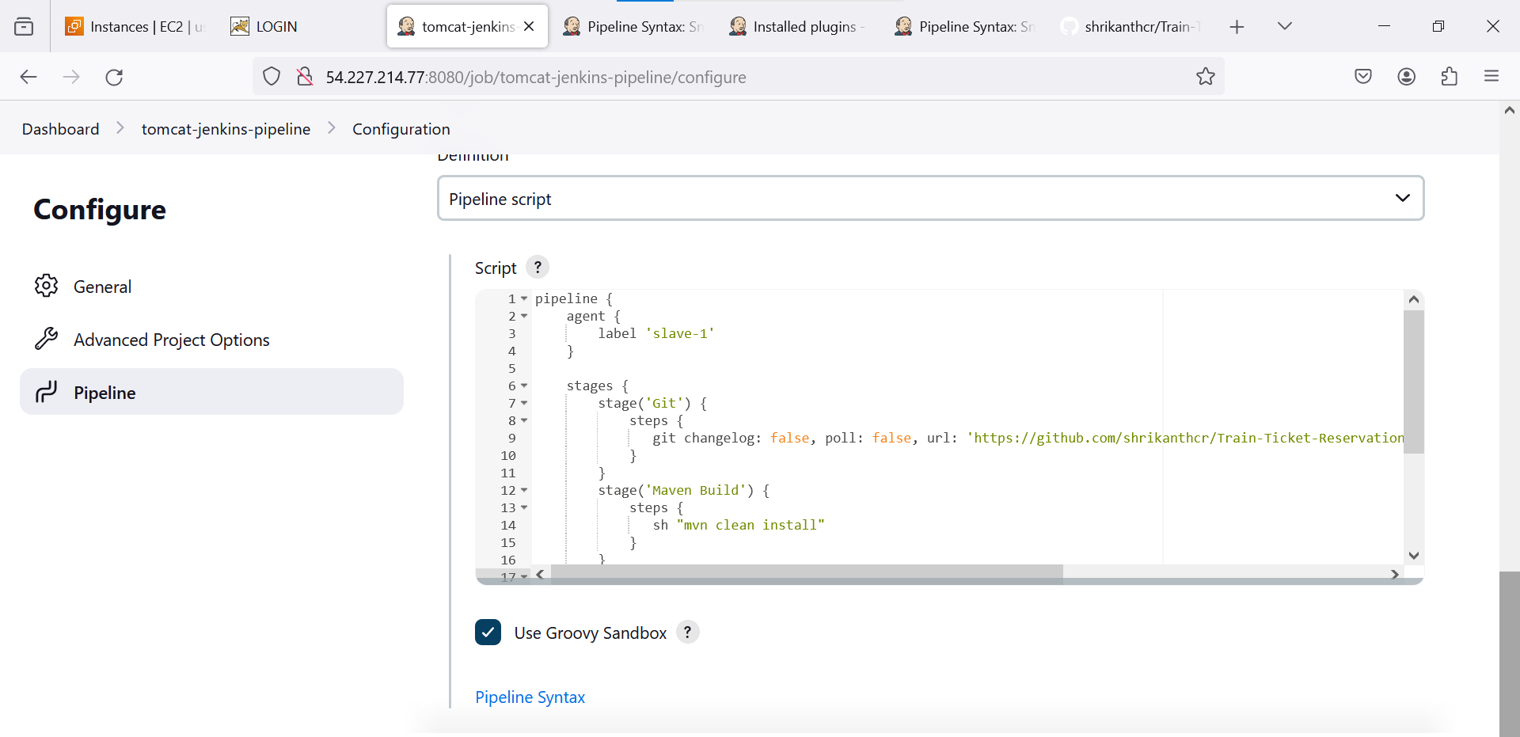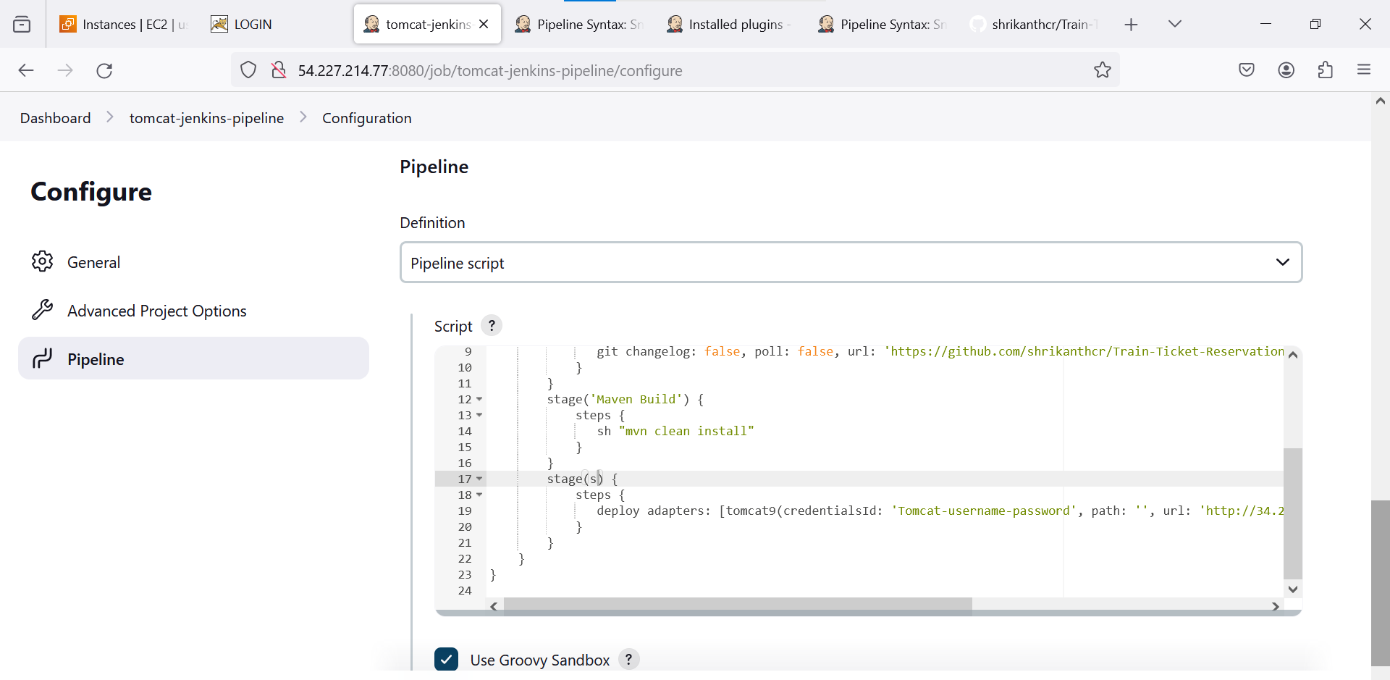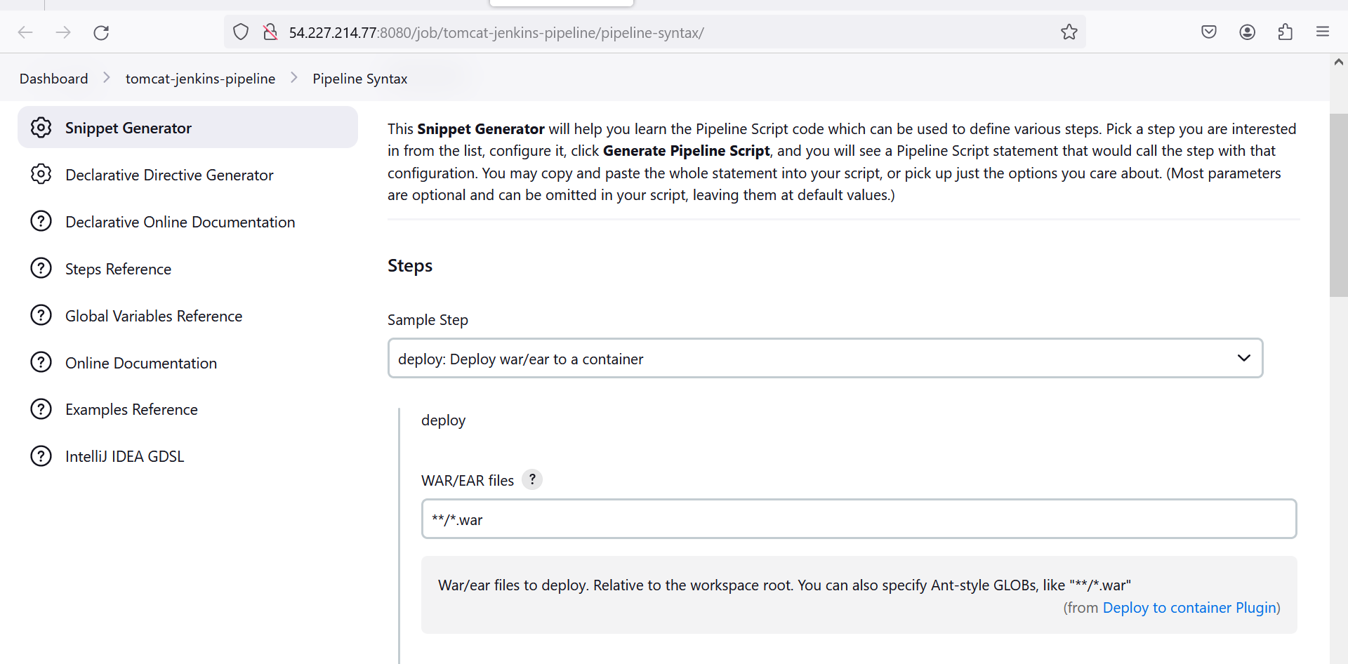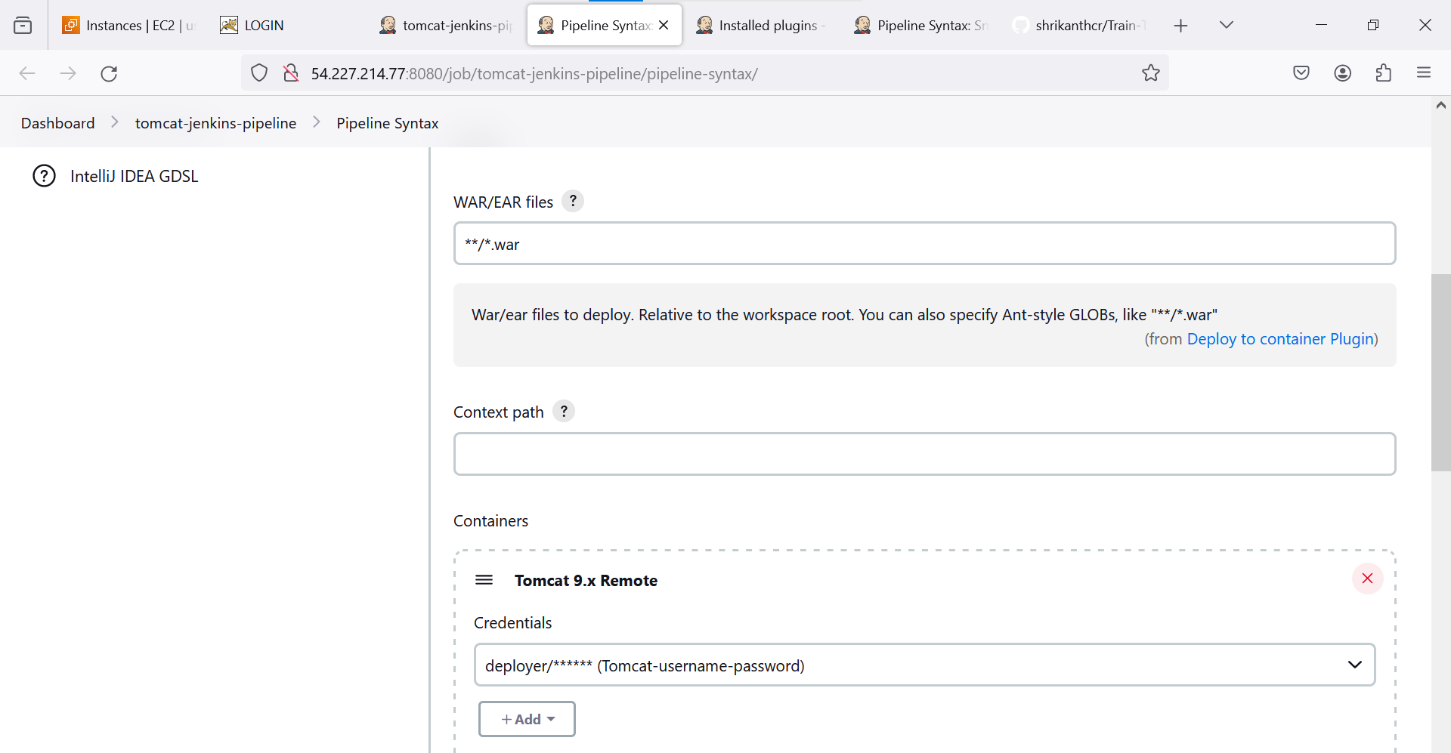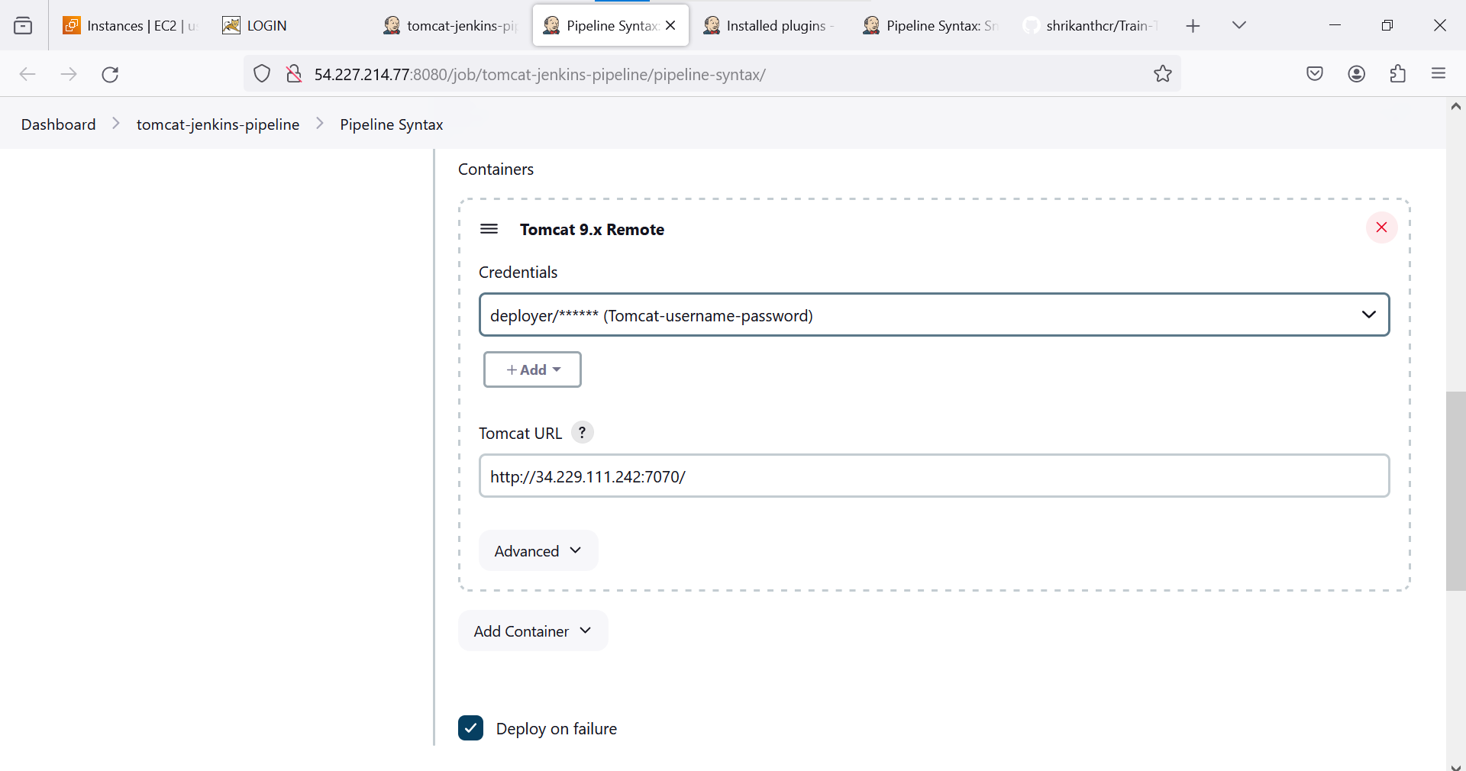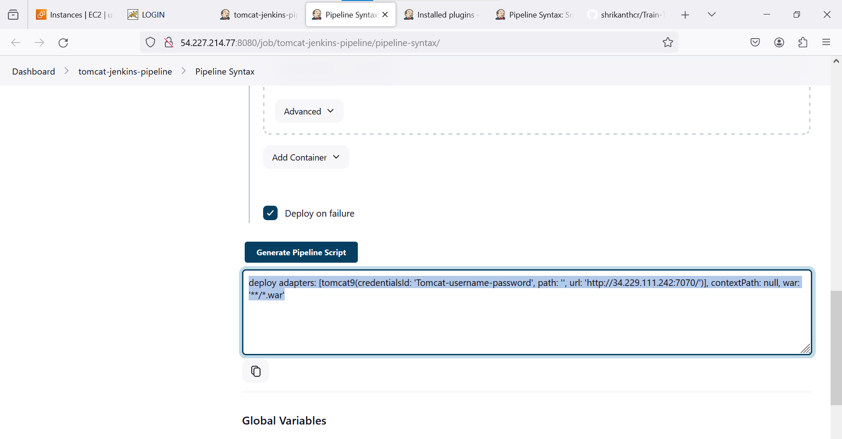 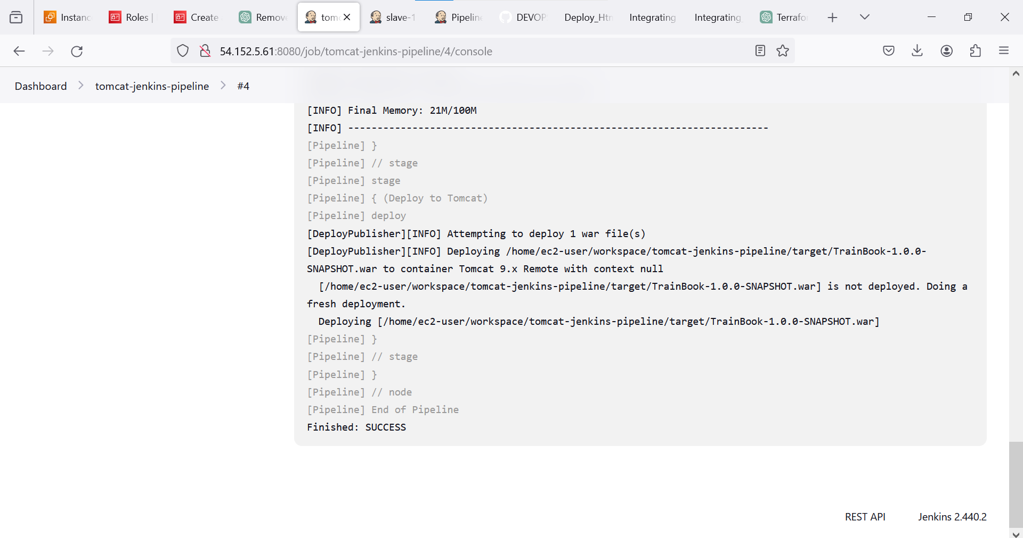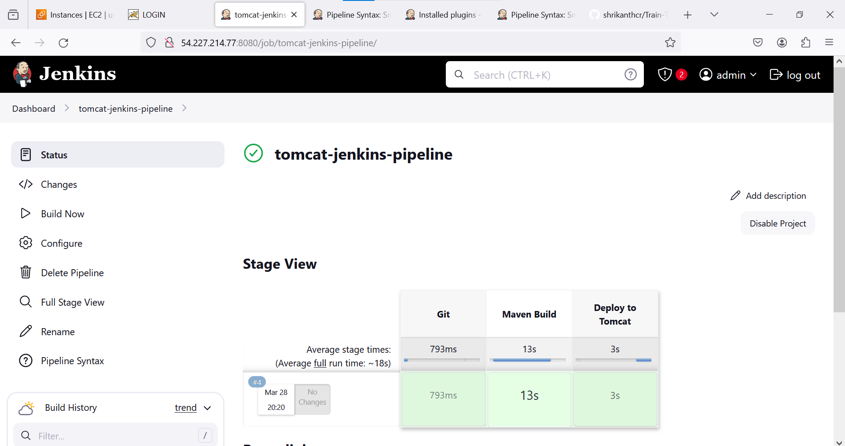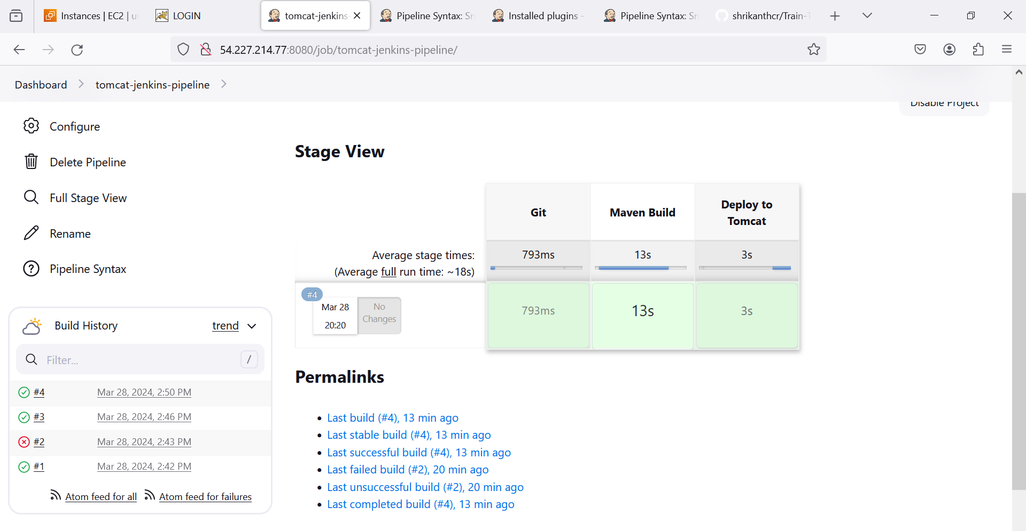 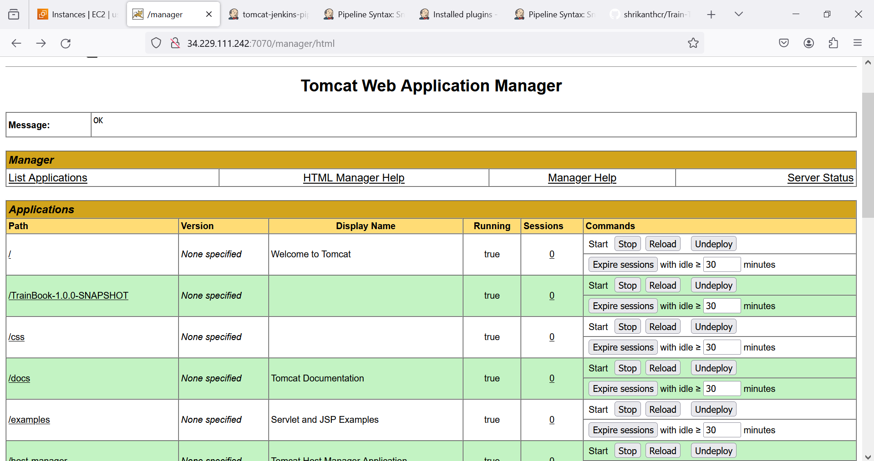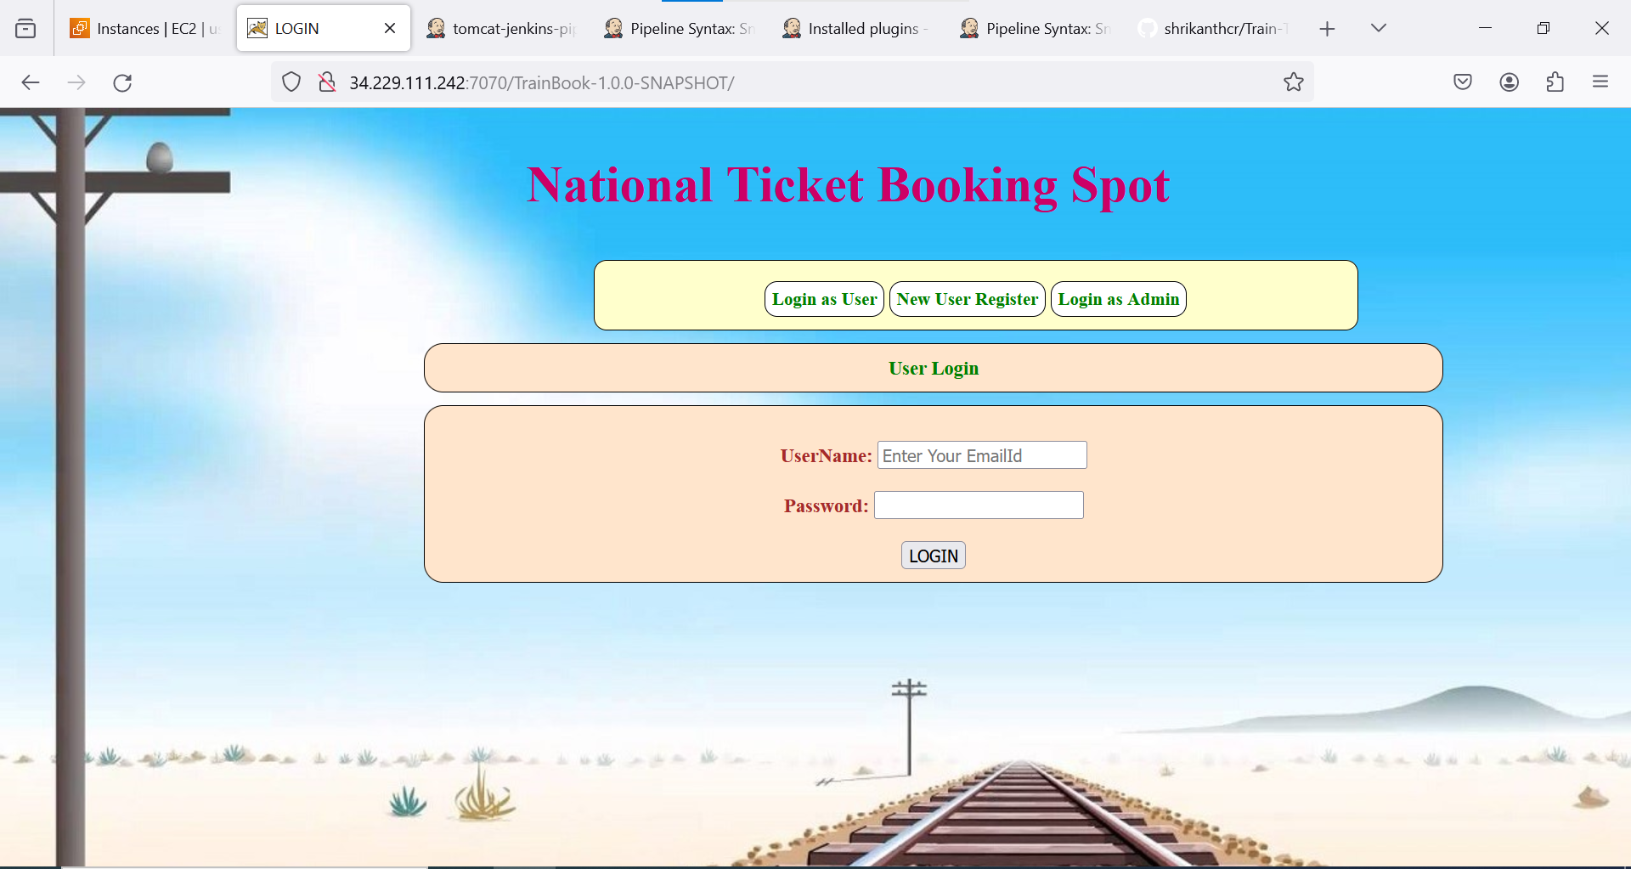

pipeline {

agent {

label 'slave-1'

}

stages {

stage('Git') {

steps {

git changelog: false, poll: false, url: 'https://github.com/shrikanthcr/Train-Ticket-Reservation-System.git'

}

}

stage('Maven Build') {

steps {

sh "mvn clean install"

}

}

stage('Deploy to Tomcat') {

steps {

deploy adapters: [tomcat9(credentialsId: 'Tomcat-username-password', path: '', url: 'http://34.229.111.242:7070/')], contextPath: null, war: '**/*.war'

}

}

}

}